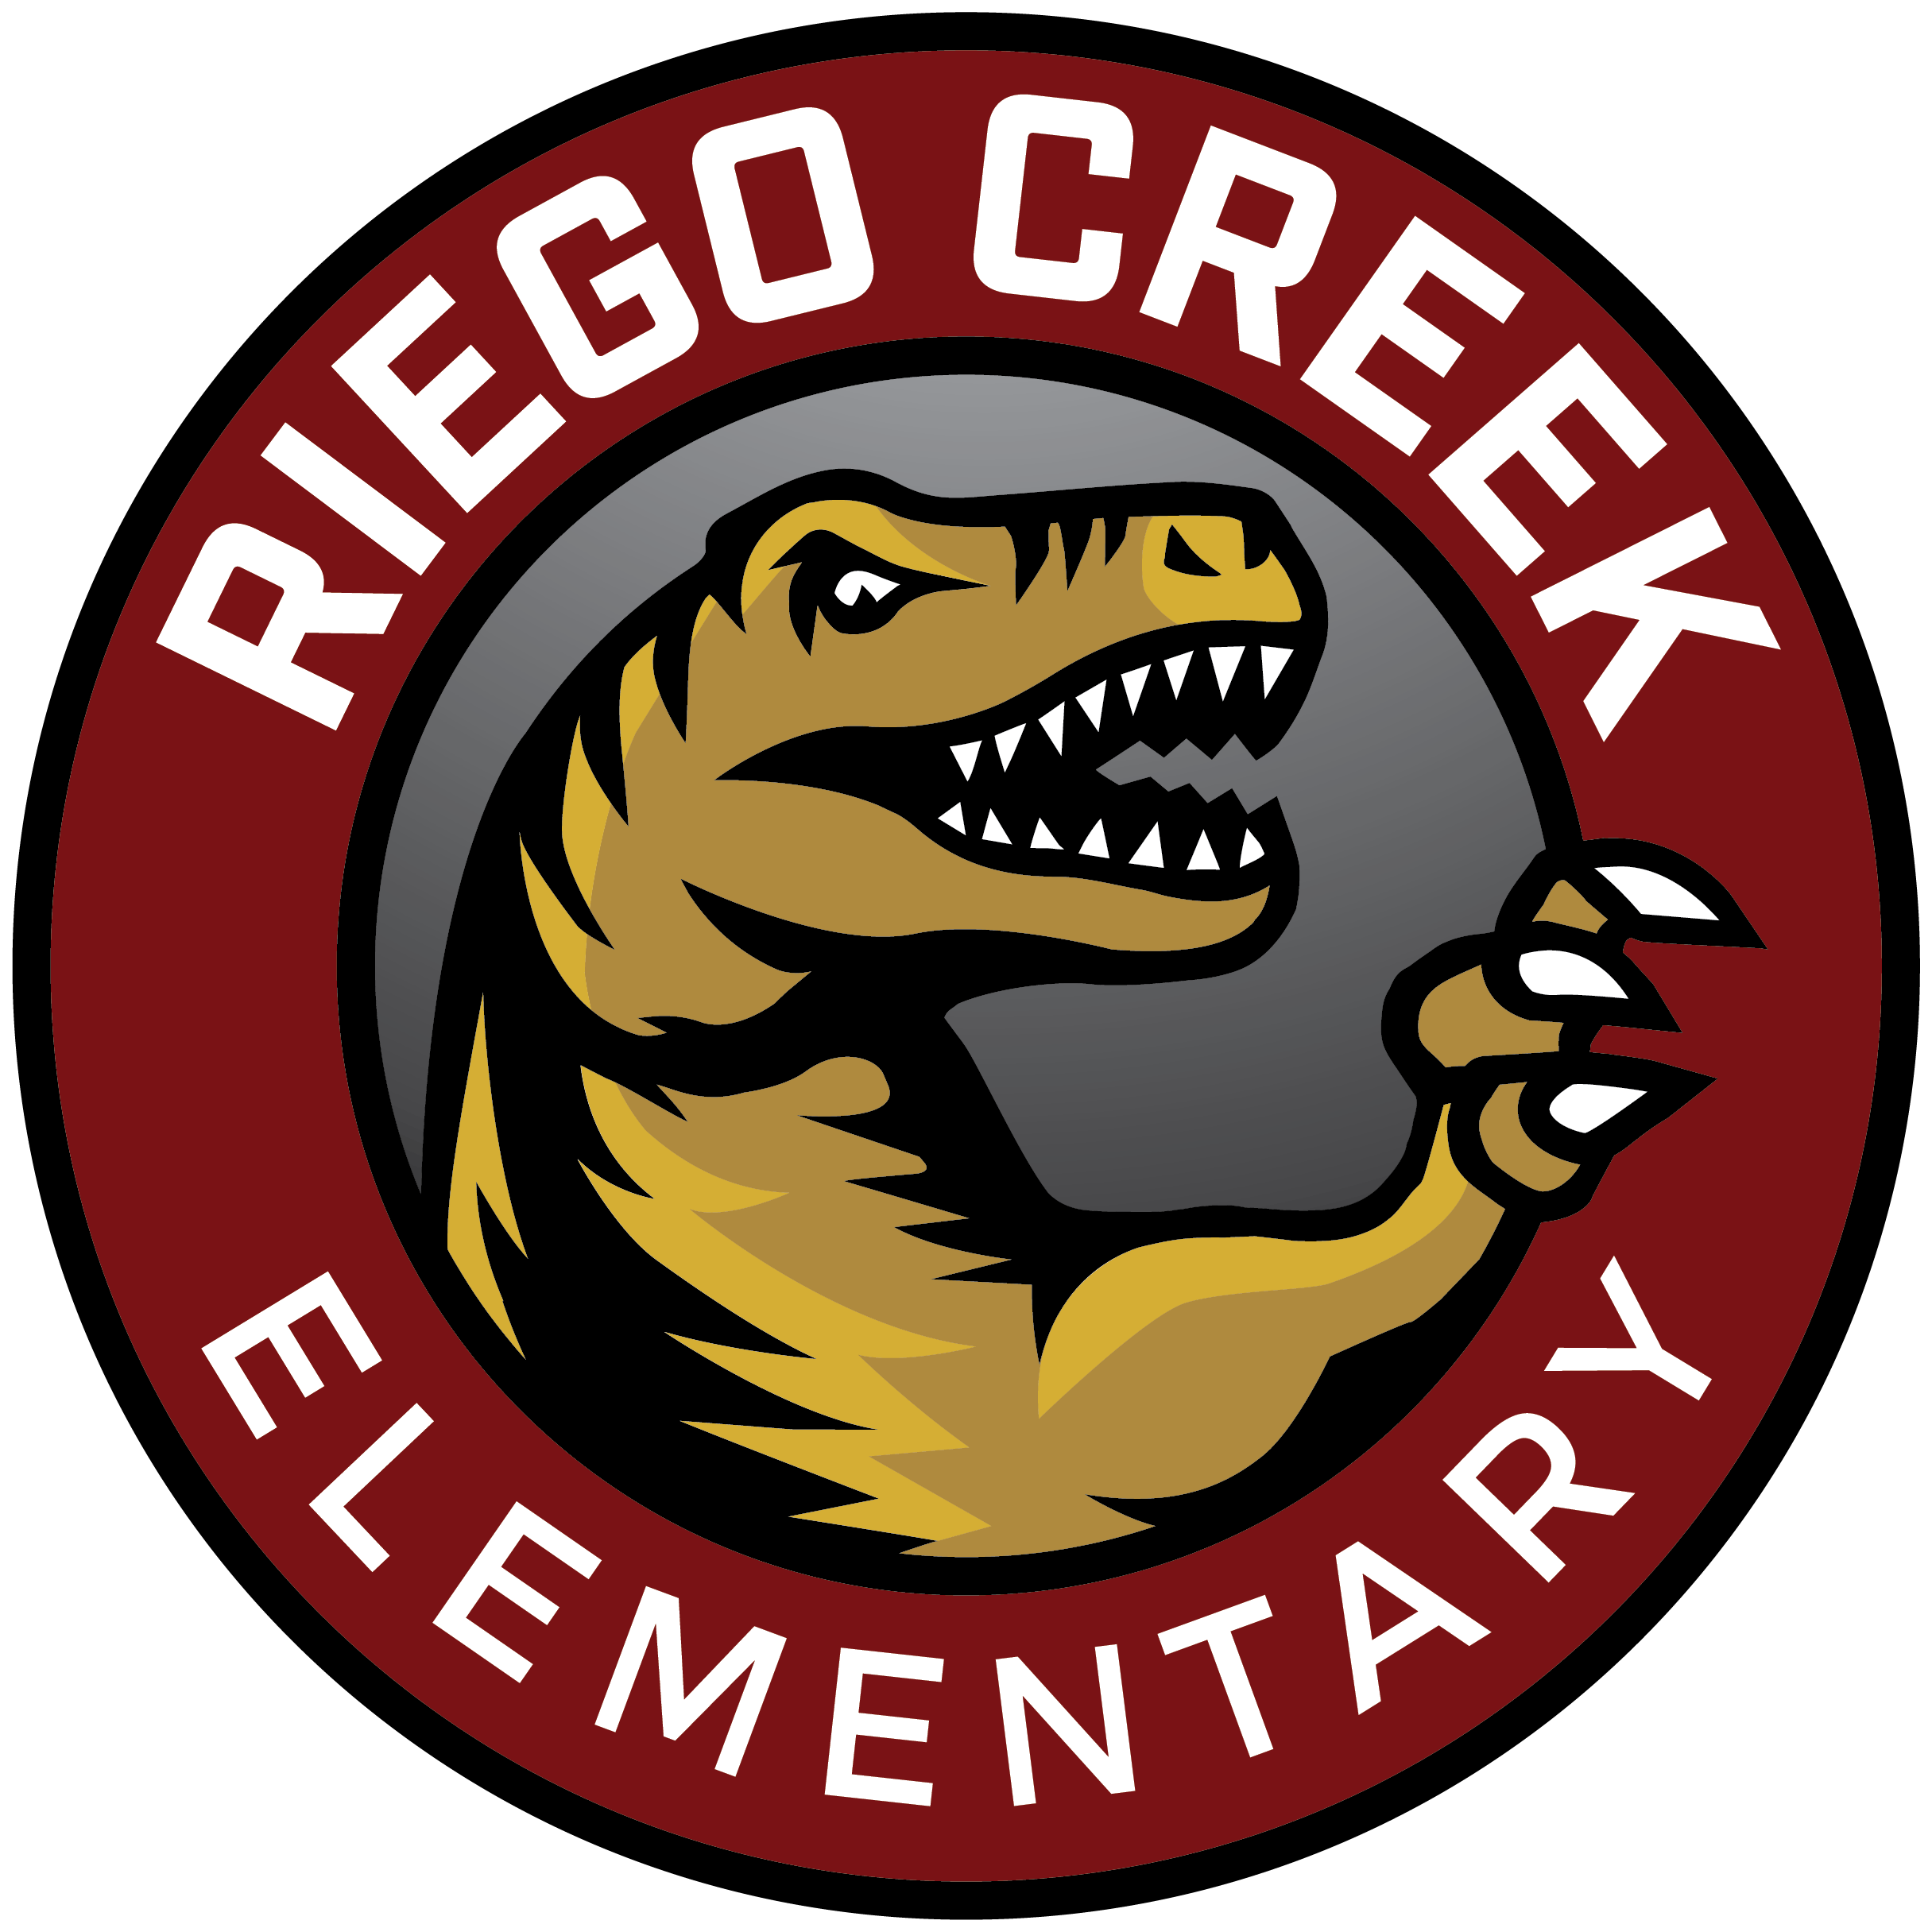 | RAPTOR NEWS
Mr. Villalpando | August 14th, 2020

Hello Riego Creek Families,

Our entire Riego Creek Team wants to thank you for a very productive and exciting first week of school. We understand that things are still a work in progress but we are committed to ensuring we get better each day.

Your child’s teacher will continue to work with you on updates and information about your child’s schedule. Many teachers will start iReady assessments for both reading and math next week. We do ask that you remind your child that we are looking to see what they know at this time. Please know these assessments are to guide our team in developing next steps in your child’s learning plan.

As you prepare for next week, know we are here to help. Please give us a call if you need technical assistance, materials, or assistance with supporting your child with their daily activities.

We are very appreciative of all your support and cooperation as we help all our mini-raptors achieve their full potential.

PTC Updates
Please enjoy a message from our Interim PTC President Video Message

- PTC Board position Elections will be Friday, August 21st. Ballots will be sent electronically to all families
- Sami Circuit Virtual Events starting Monday, Aug. 24th (Date is different from Video)
- PTC Fundraiser coming early September (More information to come)

Raptor Swag
We want to welcome our Mini-Raptor with a few gifts. Every student will receive a Raptor T-Shirt, Raptor Commemorating Coin, and Memory Tile next week. We will have Swag Deployment on Friday, August 21st from 9 am to 4 pm.
- Raptor Memory Tile - all our students will receive a tile to decorate as a foundational member of Riego Creek. Every tile will be hung on the wall in the main office.

Thank you again and enjoy your weekend.

Respectfully,
Mr. Villalpando

