|  |  |
| --- | --- |
|  | **RAPTOR NEWS** |
| **Mr. Villalpando** | **August 25th, 2020** |

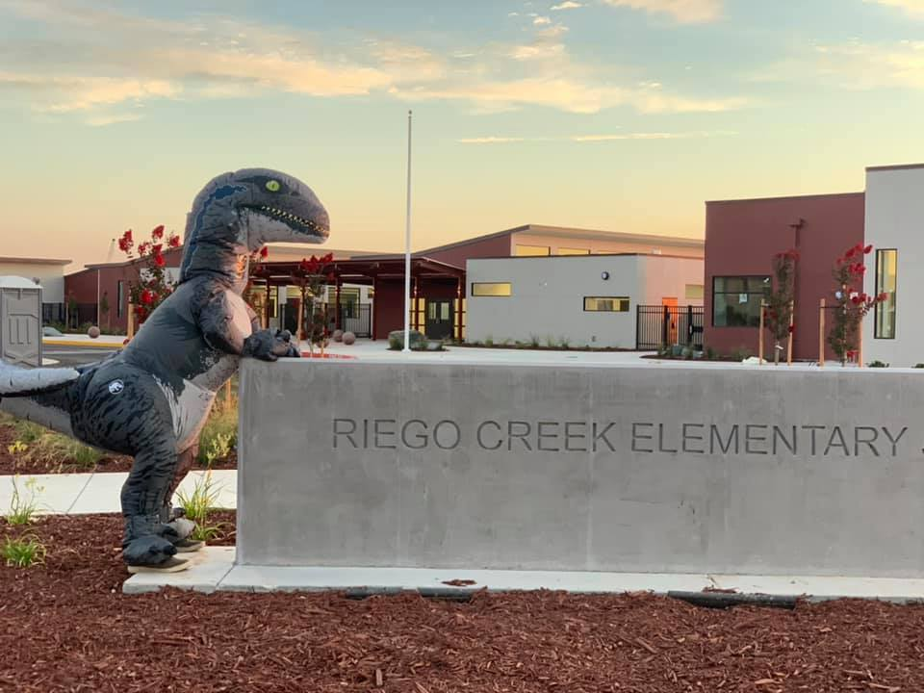

**PTC Election Results**

* **President - Sarah Carder**
* **VP of Events - Hannah Danbacher**
* **VP of fundraising - Irene Buck**
* **Secretary - Carla Pudwill**
* **Treasurer - Jen Mink**
* **Social Media - Cindy McPhail**
* **Financial Secretary - Open at the time**

Hello Raptor Families,

Thank you for taking the time to elect our PTC Board. We had a number of incredible parents/guardians who decided to take the leap into these crucial roles for our Mini-Raptors. Over the next few weeks, we will have video introductions for each of our new PTC Board members.

**Our PTC Board will send out information for our next PTC meeting.**

Respectfully,

Mr. Villalpando