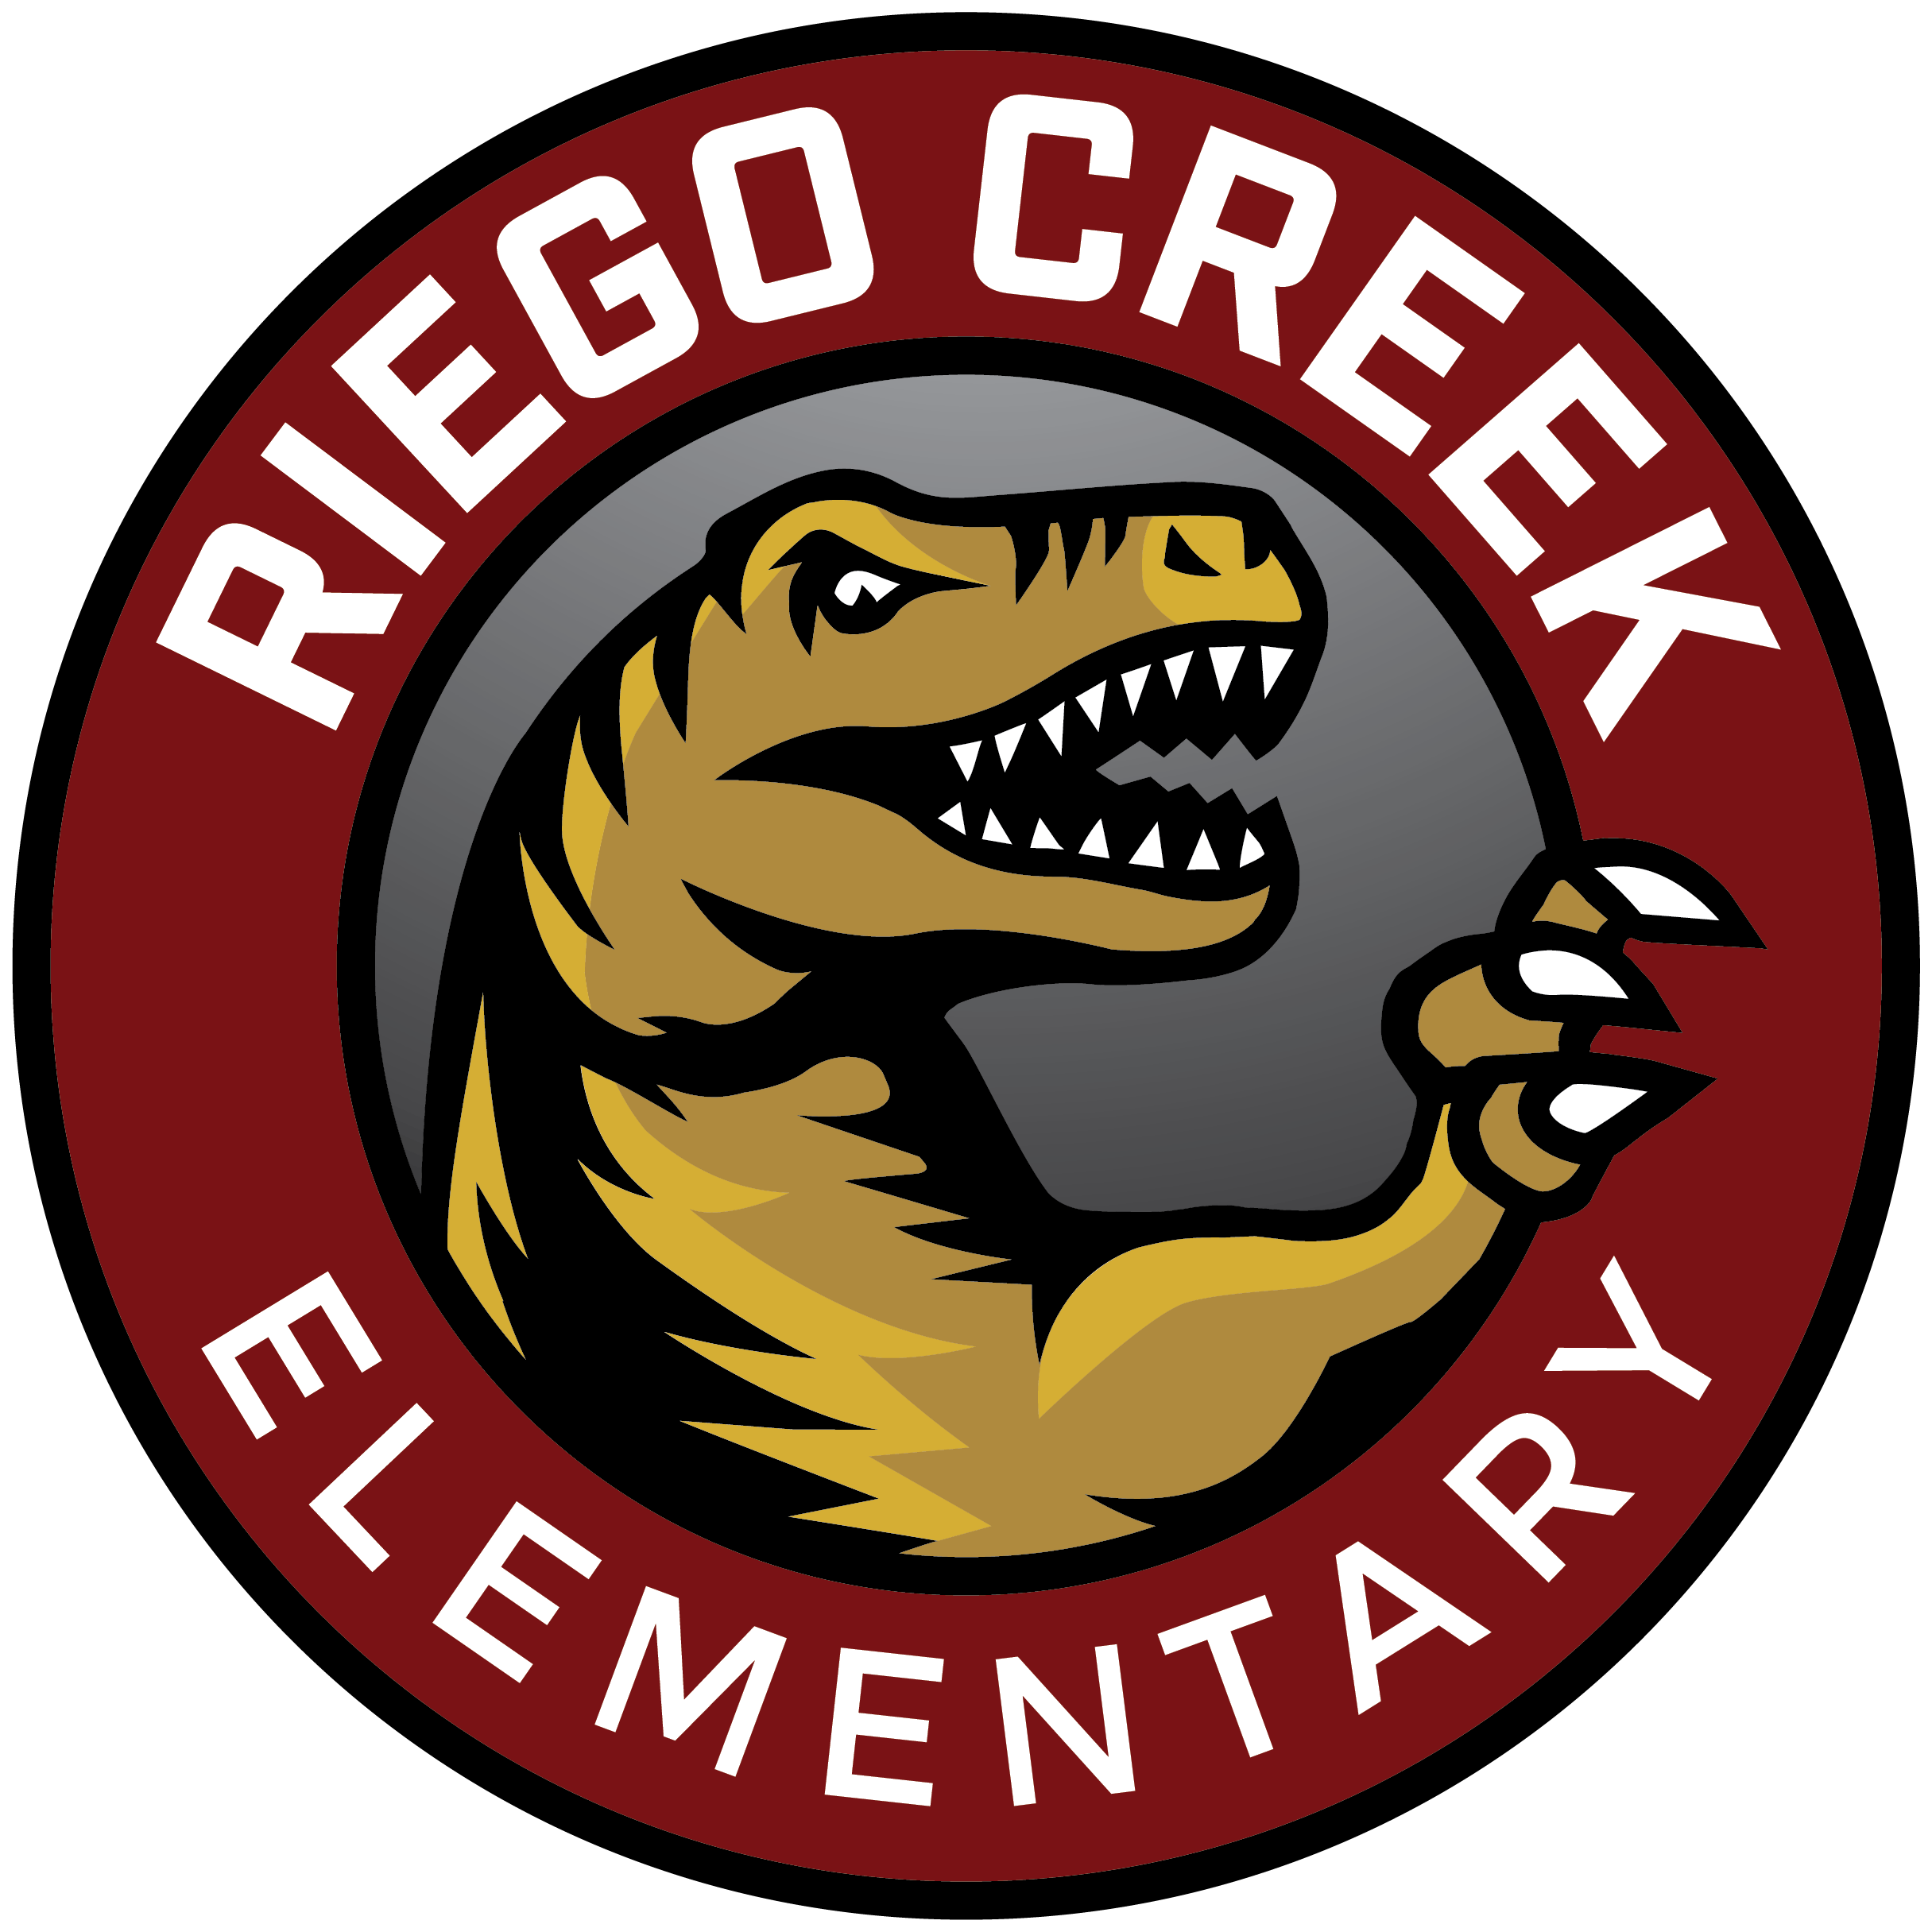 | RAPTOR NEWS
Mr. Villalpando | August 31st, 2020

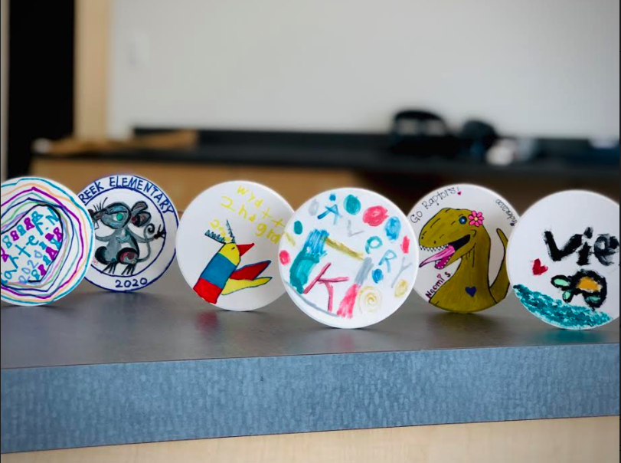
Sample Memory Tiles from our Mini-Raptors
Please drop off your Memory Tile at the Front Office at your earliest convenience.

Hello Raptor Families,

Welcome to another week at Riego Creek. As we enter this week, please know we truly appreciate your support, feedback, and resiliency as we continue to refine our process and procedures to meet the needs of all our Mini-Raptors. I have attached to this message a video of some upcoming events as well as a few documents outlining our new school schedule starting Tuesday, September 8th, and our future Material Deployment. Please note that our PTC Fundraiser information will be sent out soon.

Mr. V's Video Message

Respectfully,
Mr. Villalpando

