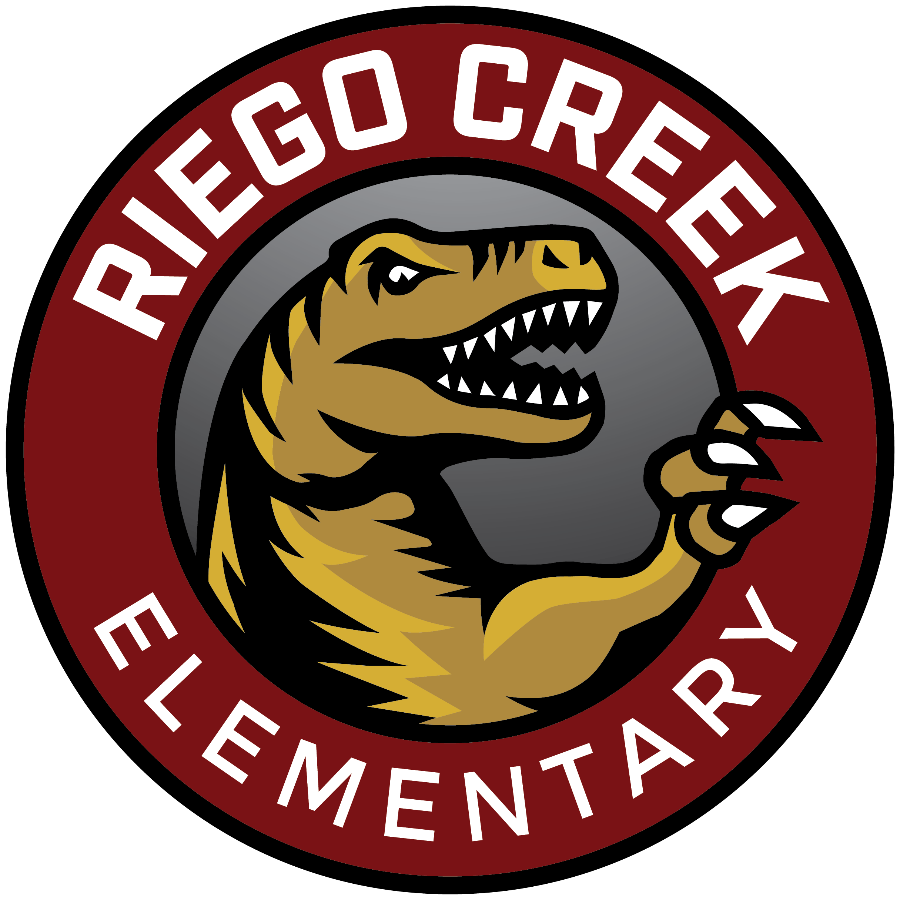 | RAPTOR NEWS
Mr. Villalpando | August th, 2020

Hello Riego Creek Families,

We know this “Back to School Night” is different than most. We wanted to give you more details about how to log on to see your child’s teacher’s video.

First, it does not matter if you log in as a student or a parent. You should have received an email from the school site with your child’s unique Otus ID for the family account, and a separate email with the student ID number for them to log in. Please see the guides below for more information.

Create a Family Account/Spanish Family Account Guide
Student Log In- Clever and Otus

The message will be placed in your child’s Classboard inside the Otus platform. The message will be available at any time, and you do not have to watch it right at 4 pm.

Exploring Bookshelf or Classroom, Parent and Student View

Thank you again for all your support. Students should log into their Clever and Otus account (not the parent account) on Monday morning as a reminder.

Monday Student Login Directions

We look forward to working with your child at 8:10 am on Monday!

Respectfully,

Mr. Manny Villalpando
Riego Creek Elementary - Principal

